**5. DETAILED DESIGN**

**5.1 Introduction**

Detailed design is the second level of the design process. During detailed design, we specifyhow the module in the system interacts with each other and the internal logic of each of the modules specified during system design is decided, hence it is also called as logic design.

Detailed design essentially expands the system design and database design to contain a more detailed description of the processing logic so that the design is sufficiently for coding .

Detailed design essentially expands the system design and database design to contain a more detailed description of the processing logic and data structures so that the design is sufficiently complete for coding.

**5.2Applicable Documents**

The detailed design refines the System Design document hence the first applicable document here is system design .We also refer the data structures.Hence the second applicable document is database design.

**5.3 Structure of the software package:**

The functional components are:

* Admin module
* Customer module

**5.4 Modular Decomposition Components**

**5.4.1 Admin Module**

**Design assumption:**

This module is designed in such a way that it allows the administrator to use any of the options easily so that he can add ,delete, modify or update ,block any details.

**5.4.2 Identification of modules**

This involves following options:

* Manage customer
* Update product details
* View product details

**5.4.3 Structure chart for admin:**

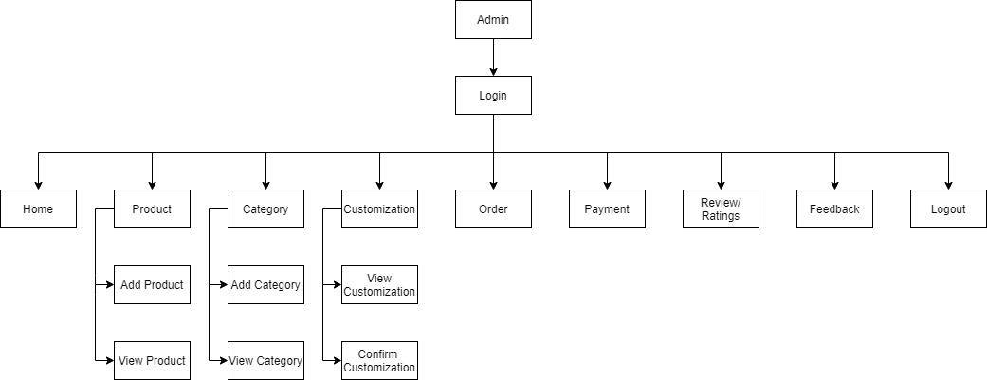

**Modules of Admin:**

* Login
* Product
* Category
* Customization
* Order
* Payment
* Review/ratings
* Feedback

**Identification module description:**

* **Login**

**Input:** a_id, a_username, a_password.

**Output:** The admin logs in to the application and is headed to the home page.

* **Product**

**Input:** p_id, cat_id, p_name, p_image, p_price, p_desc.

**Output:** Product details are stored and displayed.

1. **Category**

**Input:** cat­_id, cat_name.

**Output:** Category details are stored and displayed.

1. **Customization**

**Input:** cust_id, p_id, customization.

**Output:** Customized details are displayed.

1. **Order**

**Input:** o_id, c_id, p_id, quantity, price , total.

**Output:** Order details are displayed.

1. **Payment**

**Input:**pay_id,o_id,c_id,pay_code,pay_method,pay_amount, pay_status, pay_date.

**Output:** Payment details are stored and displayed.

* **Review/Ratings**

**Input:** r_id, c_id, p_id, rating, review, r_date.

**Output:** The ratings/reviews are displayed.

* **FeedBack**

**Input:** f_id, c_id, feedback, date.

**Output:** The feedback details are displayed.

**5.4.4 Structure chart for Customer:**

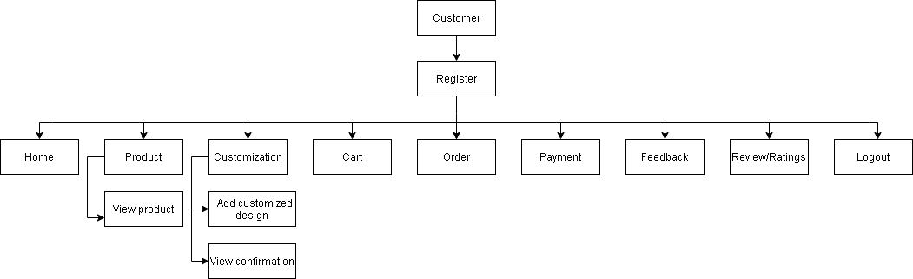

**Modules of Customer:**

* Login
* Product
* Customization
* Order
* Payment
* Feedback
* Review/Ratings
* Logout

**Identification module description:**

1. **Login**

**Input:** c_id, c_name, c_email, c_password, c_phone, c_address.

**Output:** The Customer logs in to the application and is headed to the home page.

1. **Product**

**Input:** p_id, cat_id, p_name, p_image, p_price, p_desc.

**Output:** Product details are stored and displayed.

1. **Customization**

**Input:** cust_id, p_id, customization.

**Output:** The customization details are stored and displayed.

1. **Order**

**Input:** o_id, c_id, p_id, quantity, price , total.

**Output:** The order details are stored and displayed.

1. **Payment**

**Input:**pay_id,o_id,c_id,pay_code,pay_method,pay_amount, pay_status, pay_date.

**Output:** Payment details are stored and displayed.

* **Review/Ratings**

**Input:** r_id, c_id, p_id, rating, review, r_date.

**Output:** The ratings/reviews are displayed.

* **FeedBack**

**Input:** f_id, c_id, feedback, date.

**Output:** The feedback details are displayed.